Mom Blog Analysis: Cup of Jo

Blog Overview
Cup of Jo (cupofjo.com) is a lifestyle blog founded in 2007 by Joanna Goddard, a former Cosmopolitan editor based in Brooklyn, New York. Refinery29 dubbed Goddard the "Queen of the Blogosphere," and the site receives 5.5 million monthly page views and approximately 1 million unique visitors per month.
The blog covers style, food, design, travel, relationships, and motherhood. Its tagline -- "Come for the blog, stay for the comments" -- captures what sets it apart: posts regularly draw 100-300+ reader comments, making it feel like a community rather than a broadcast. Revenue comes from clearly labeled sponsored posts, affiliate links, and brand partnerships with companies including J.Crew, Nordstrom, Outdoor Voices, and Sezane.

Post 1: "10 Things I Never Travel Without"
Published: May 14, 2026 | Category: Travel | Comments: 266
URL: cupofjo.com/2026/05/14/10-things-i-never-travel-without/
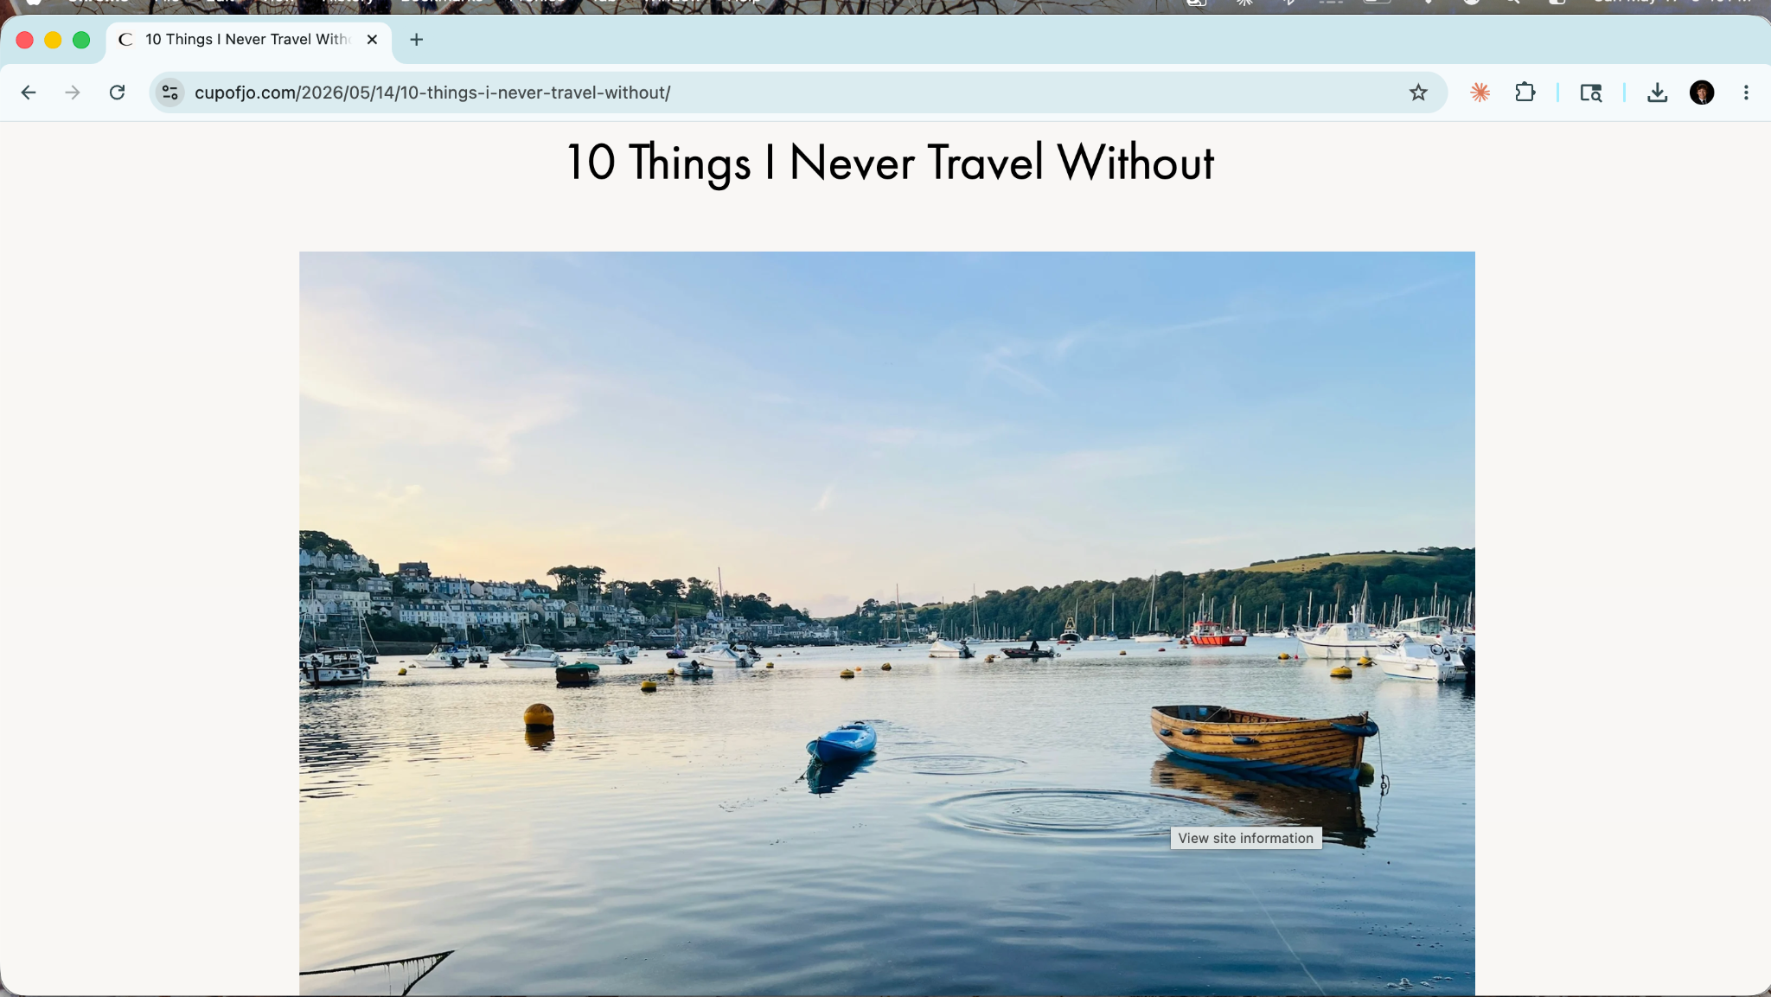

Topic & Content: Joanna Goddard shares a personal list of 10 must-pack travel items: a bedside alarm clock, sunscreen (Trip brand), self-tanning lotion (St. Tropez), stamps for postcards, a deck of cards, quick-dry nail polish (Dazzle Dry), hairspray (Elnett), a gripping book (A Private Man), chocolate (Tony Chocolonely), and sunglasses. The list blends practical staples with quirky personal touches -- stamps and a deck of cards are the unexpected inclusions that make it memorable.
Images: Warm, authentic lifestyle photography from actual family holidays -- Cornwall harbor boats, an Italian beach club, a pub games table. No staged product shots. The photos feel personal and pull the reader into Joanna's life, which is exactly the right fit for a personal packing list post.
Links & Affiliates: Multiple affiliate links via ShopMy and Amazon, each pointing to a specific product. The book is linked through Bookshop.org. Internal links connect to related posts -- a chocolate taste test and a travel tips roundup -- keeping readers on the site.
Branded Sponsors: None. This is purely editorial with organic affiliate links, which makes the recommendations feel more trustworthy because nothing is being sold outright.
Strengths: The conversational tone is the biggest asset. Lines like "Okay, I'm a nerd, but..." and the confession about past tanning salon visits make Joanna feel like a real person. The question at the end -- "What little things do you pack for trips?" -- turns a one-way post into a two-way conversation, which explains the 266-comment count. The unexpected items (stamps, deck of cards) create memorability that a standard "10 travel essentials" list would not.
Weaknesses: Some items (sunscreen, sunglasses) are obvious enough to feel like filler. The affiliate links, while non-disruptive in tone, could feel slightly commercial to readers who look closely. The list format sacrifices storytelling depth for scanability.
Content-Branding Fit: Strong. The absence of a formal sponsor makes the post feel genuine and builds the trust that makes other sponsored posts on the blog more effective.

Post 2: "A Summer Capsule Wardrobe" (Sponsored)
Published: May 12, 2026 | Category: Style / Sponsored | Comments: 125
URL: cupofjo.com/2026/05/12/a-summer-capsule-wardrobe/
Sponsor: Sezane -- a women-owned French fashion brand
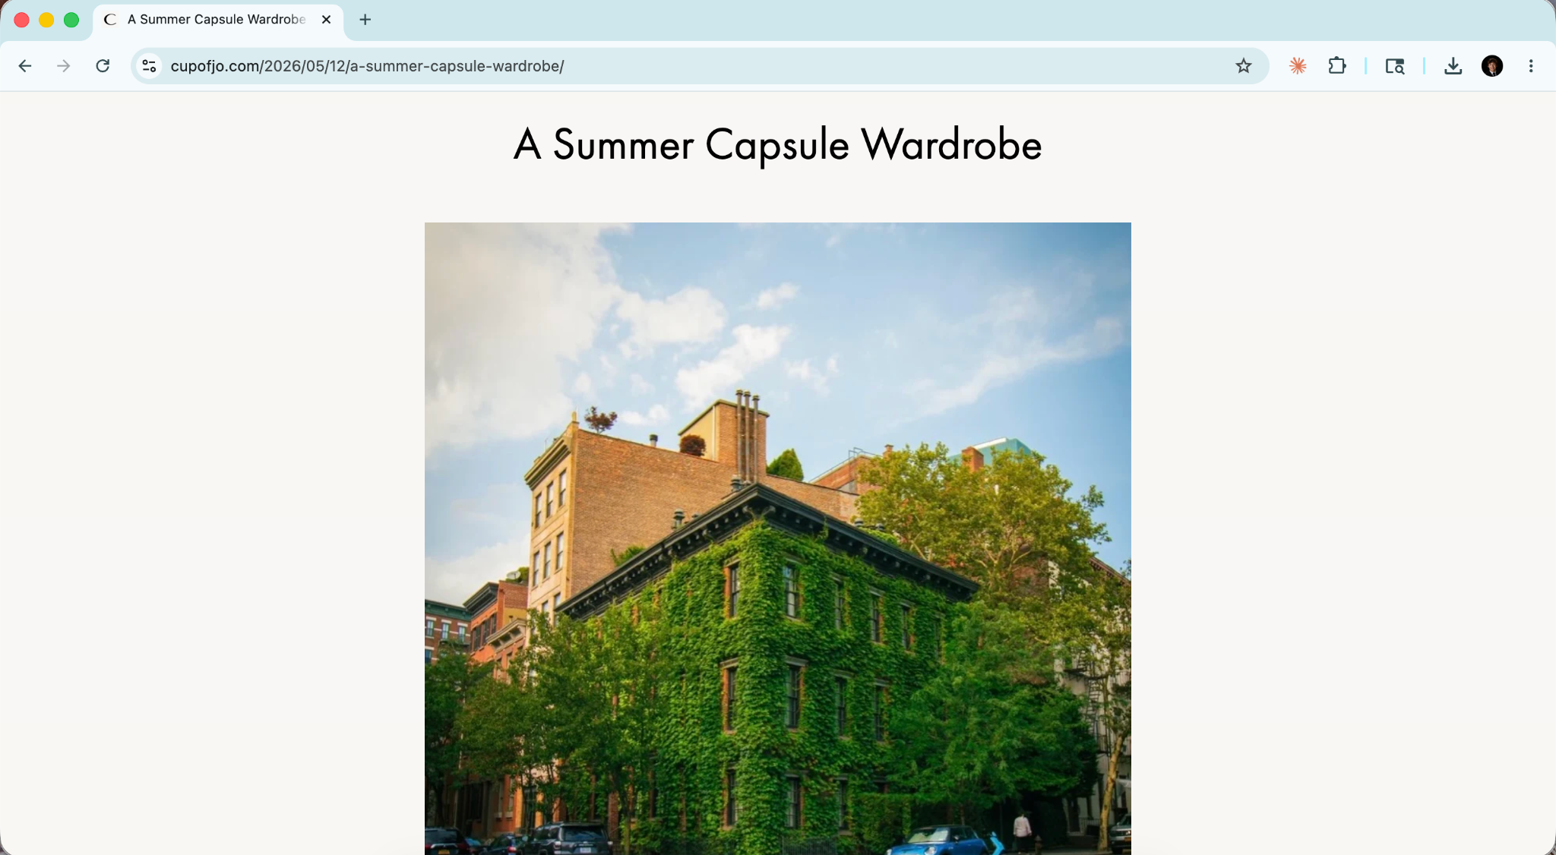
Topic & Content: Joanna presents six Sezane summer wardrobe essentials: a T-shirt with a lace-cuff detail, a mini dress, a pointelle tank, a jean skirt, strappy sandals, and a raffia bag. Each item gets a brief evocative scenario -- "after a long summer day, nothing feels better than having a shower and pulling on a clean dress, then heading outside for olives and chips" -- designed to help the reader picture herself in the clothes.
Images: A mix of NYC lifestyle shots (West Village) featuring Joanna in Sezane pieces, plus some product photography. Using the blogger's own lifestyle photos rather than just brand assets is the right call -- it puts the product in context and keeps the post feeling editorial rather than like a catalog.
Links & Affiliates: All product links go to Sezane via affiliate tracking (affilae.com). Two internal Cup of Jo links appear at the end, helping maintain SEO and keeping readers on the site.
Branded Sponsors: Sezane is both the sponsor and the sole retailer. Disclosure is exemplary: labeled "Sponsored" in the category tag at the top, and explained plainly at the bottom: "This post is sponsored by Sezane, a women-owned brand we've loved and worn for the past decade." The word "decade" does quiet but important work -- it signals a long-standing genuine relationship, not a one-off paid placement.
Strengths: The writing does not feel like an advertisement. Joanna uses the same warm first-person voice she uses everywhere, which means the sponsored content does not break the reading experience. The "women-owned" detail resonates with Cup of Jo's audience. The capsule wardrobe format is a natural fit for Sezane's aesthetic -- French, refined, quality over quantity. When sponsor and voice align this well, readers are more likely to click and convert.
Weaknesses: Every link goes to one brand, which limits variety and can feel restrictive. The comment count (125) is notably lower than the travel post (266), confirming that editorial content outperforms sponsored content for engagement -- a pattern common across the blog world.
Content-Branding Fit: Excellent. Sezane is an ideal Cup of Jo sponsor: European sensibility, ethical brand story, quality-focused, and genuinely on-brand for Joanna Goddard's aesthetic. This is a textbook example of a brand selecting a blogger whose identity already endorses their product.

Post 3: "Adventures in Wigland"
Published: May 13, 2026 | Category: Motherhood | Comments: 107
URL: cupofjo.com/2026/05/13/adventures-in-wigland/
Author: Meaghan O'Connell (contributing writer; author of And Now We Have Everything)
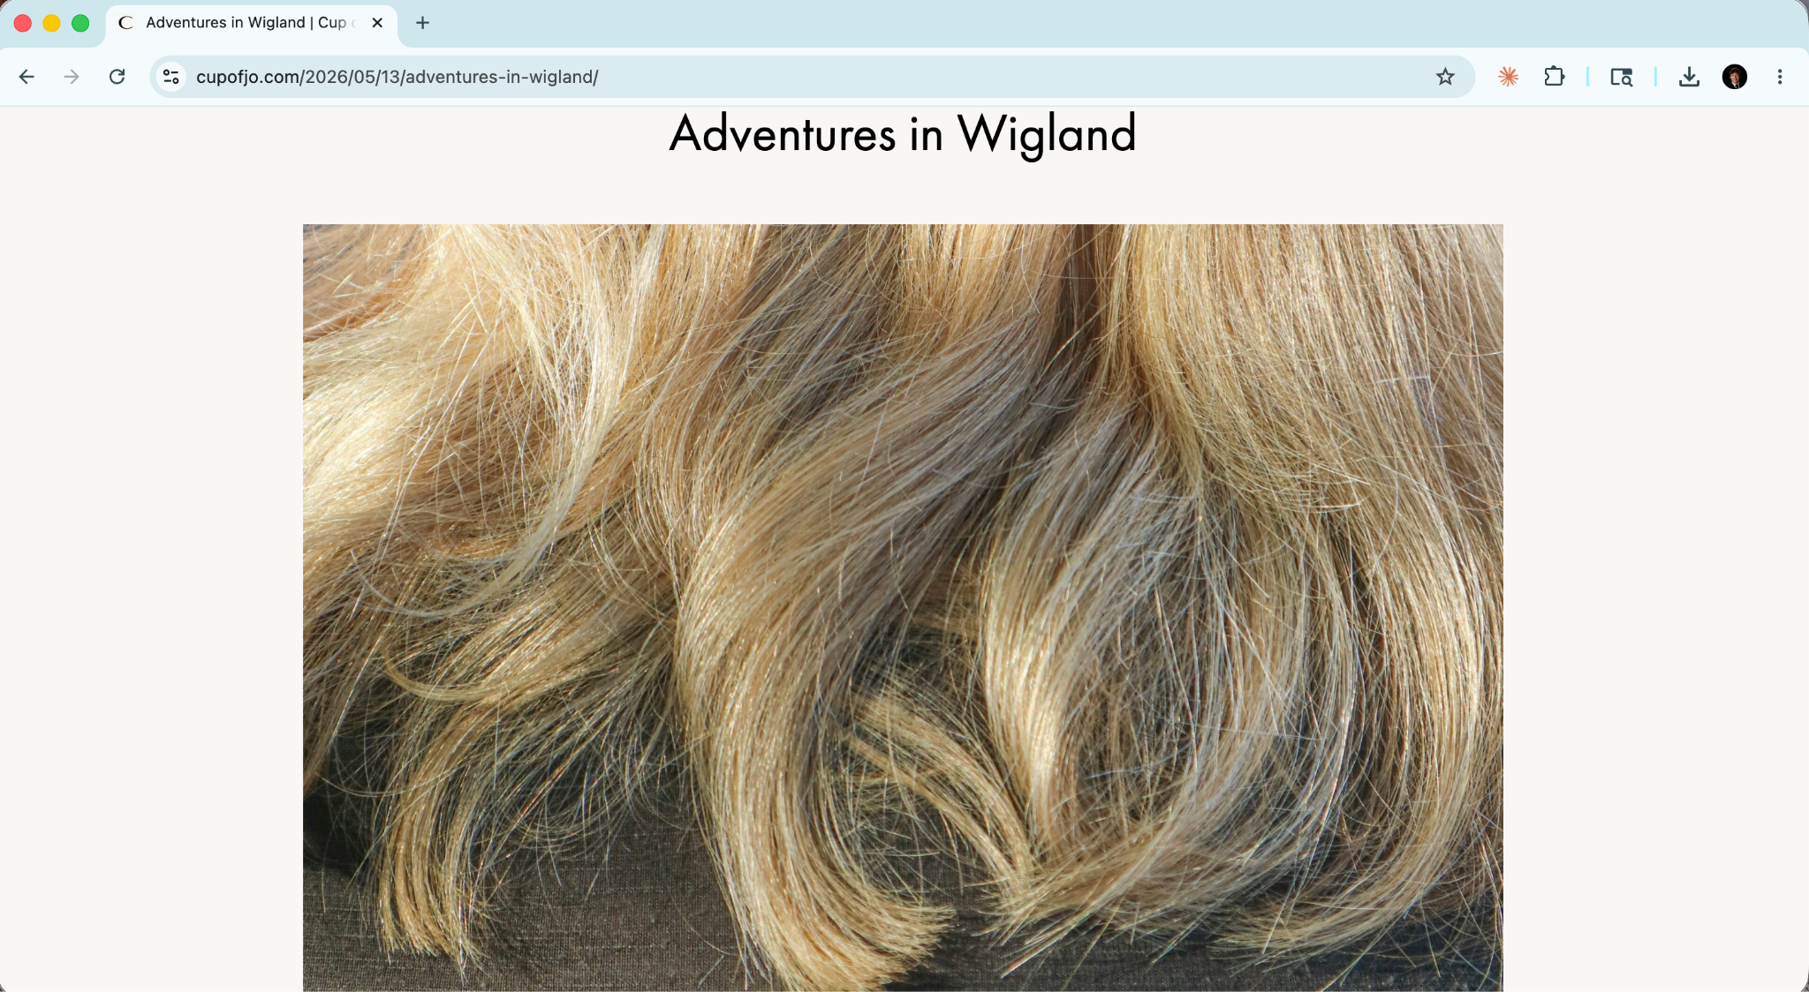

Topic & Content: A personal essay by contributing writer Meaghan O'Connell. The piece follows O'Connell accompanying her mother -- who is undergoing cancer treatment and has lost her hair -- to shop for a wig. Opening line: "'I'm ready for a wig,' my mom declares." The essay is tender, funny, and emotionally rich, centering on the mother-daughter dynamic during serious illness.
Images: A single editorial-style lead image rather than product photography. The visual restraint matches the subject matter and feels appropriate.
Links & Affiliates: No product links or affiliate placements. The only links are to O'Connell's author page and her book on Bookshop.org. This is 100% editorial.
Branded Sponsors: None. Pairing a cancer treatment essay with product placements would be tone-deaf. The absence of any commercial element is what makes this post work, and it demonstrates that Cup of Jo understands the difference between content that sells and content that builds trust.
Strengths: This is the type of content that separates Cup of Jo from generic lifestyle blogs. Personal essays about health, aging parents, and caregiving resonate deeply with the blog's core demographic -- women in their 30s and 40s navigating similar experiences. With 107 comments on a piece with no commercial hook, the engagement proves the audience values emotional depth. Essays like this build the loyalty that makes readers trust every other post on the site, including the sponsored ones.
Weaknesses: The lack of visual variety reduces shareability on image-driven platforms like Pinterest. Readers who come for aspirational lifestyle content may find the subject matter heavy. It shifts tone significantly from the fashion and travel posts around it.
Content-Branding Fit: No branding present -- which is exactly right. This post serves an indirect commercial function: it validates Cup of Jo as a place readers can bring their full selves, deepening investment in the community and increasing receptivity to recommendations in other posts.

Would I Recommend This Blog to a Mom?
Yes, without hesitation. Cup of Jo treats its readers as full adults who also happen to be mothers, which is rare. The Motherhood section addresses real complexity -- aging parents, navigating illness with kids, raising teenagers -- without being sentimental. The lifestyle content assumes that mothers have rich, interesting identities beyond their children. The comment section is warm, civil, and active, which is increasingly rare. A mom who wants to feel understood, occasionally challenged, and regularly entertained would find Cup of Jo a genuine daily habit.

Would I Recommend This Blog to a Marketer?
Yes. Cup of Jo is one of the stronger lifestyle media properties available for brand partnerships, for several reasons. First, the audience is highly engaged: 5.5 million monthly page views, 1 million unique visitors, and hundreds of comments per post indicate an active, returning readership. Second, the demographics are clear: women aged 25-45, educated, urban-leaning, with household incomes that support premium spending on fashion, travel, food, and home. Third, Joanna's transparent disclosure practices and long-standing brand relationships build reader trust that transfers directly to product recommendations. Fourth, posts rank on Google and continue driving affiliate revenue long after publication.
Brands that align well include: fashion labels such as Sezane, Madewell, Boden, Everlane, and Anthropologie (already working with several); beauty brands such as St. Tropez, Glossier, Kiehl's, and Tatcha; home and living brands such as Parachute, Great Jones, and Crate & Barrel; travel-adjacent brands such as Airbnb and premium luggage labels like Away or Paravel; and food brands such as specialty chocolate companies or upscale grocery delivery services.
One caution: Cup of Jo's audience is sophisticated and trusts the blog precisely because it is not over-commercialized. Brands that push for hard-sell placements or misalign with the editorial voice risk visible pushback in the comments -- which, given how active that community is, would be public and damaging.

Sources
Cup of Jo -- Post 1: 10 Things I Never Travel Without
Cup of Jo -- Post 2: A Summer Capsule Wardrobe
Cup of Jo -- Post 3: Adventures in Wigland
Cup of Jo -- Wikipedia

